8TH WEEK’S REPORT

Maze Solving Robot’s Sensor Arrangement

Since the initial plan for having three sensors at the front part of the robot conclusively seem to have a lot of problems, we discussed about this again and concluded that we are going with seven sensors.

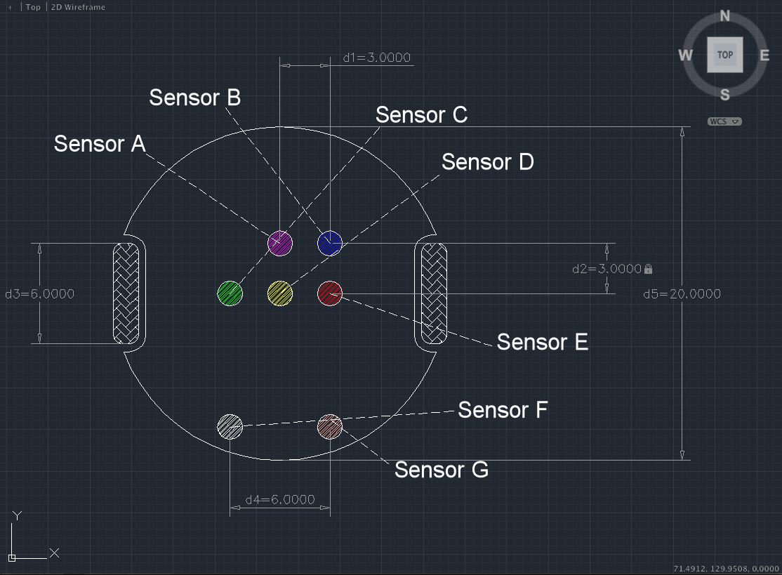
Figure 1 : The sketch diagram of the new sensor arrangement of the maze-solving robot

We decided to move the three sensors (Sensor C, D, and E) that we proposed last week to the center of the robot. This way the robot’s center would stop at the center of the pivot during turns without having to predict the time interval needed to be there, unlike our previous idea. For it to be able to distinguish + and T intersections, we put the new sensor A in front of Sensor D. To distinguish a + intersection and a finish tile, we also put the new sensor B next to Sensor A.

We also considered the smoothness of the robot’s path. This is one of the problems that were mentioned last week. To troubleshoot this problem, we decided to put the new Sensors F and G which works together with Sensors C and E to make sure the robot is going through the right path. If because of the wheel’s installment or the motor’s difference in angular velocity the robot becomes misdirected, the sensors would detect this misdirection and command the motors to align the robot straight.

For example if the left motor’s angular velocity is slightly higher than the right, the left sensor ( C ) which initially senses white would sense black. That time it would command the right motor to rotate faster than the left to rectify the robot’s path.

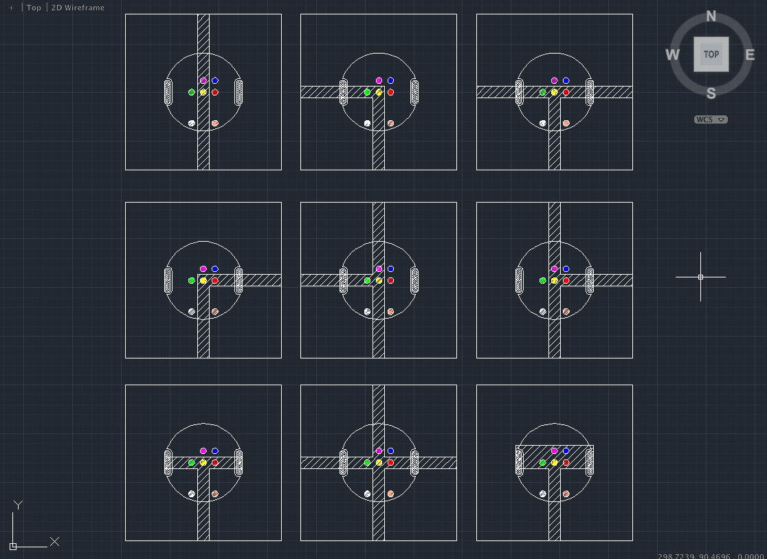
Figure 2 : The sketch diagram of the maze solving robot on different situations on various tiles

One thing we need to be careful about is the distinction between a start tile and a T intersection tile. In this case the sensors F and G would come into play. The diagram shows it wrong, but we will make the sensors F and G so that it would be far enough from the center of the robot to avoid sensing the black side lines of the start tile. In case the robot detects a T intersection or a start tile, the robot would have to rotate itself at least by 90°. During so, we make the robot sense the presence of a line when it is rotating by 90°. When it detects a line, we make the robot consider that as a T intersection and make it stop rotating after 90°. If it does not, we make the robot consider otherwise and make it rotate 180° and go back.

Research done by Richard

Sensors

In order for the robot to accurately sense its position in relation to the lines of the maze, it must be equipped with strategically placed sensors. These sensors must be capable of differentiating between black and white in a way that is precise enough for the robot to know whether it is on the black line or not, and where to start turning.

The following is a list all the sensors we've considered, and the different parameters used to select the most appropriate sensors for this project.

QTR-1A Reflectance Sensor from Polulu Robotics & Electronics
http://www.pololu.com/catalog/product/958

Arduino Infrared Reflex Close to Switch Black & White Line Tracking Sensor Module TCRT5000
http://www.goodluckbuy.com/arduino-infrared-black-and-white-line-tracking-sensor-module.html
Datasheet: http://www.vishay.com/docs/83760/tcrt5000.pdf
- Light Intensity to Frequency IC
http://www.active-robots.com/sensors/colour-light/light-intensity-to-frequency-ic.html
Datasheet: http://www.active-robots.com/fileuploader/download/download/?d=0&file=custom%2Fupload%2FFile-1343058105.pdf

- CMOS Camera -1300 x 1040
http://www.active-robots.com/sensors/camera-vision/cmos-camera-1300x1040.html

Some important considerations:

Ease of Use
The camera was eliminated from our choices because despite its high quality and accuracy, writing the algorithm for its exploration seemed too difficult, and for the time-being at least, above our skill-level. For this reason, we chose to go with simpler sensors that served only the function of differentiating between black and white. Though using a camera may have allowed for a more sophisticated robot, the maze that it is required to navigate is relatively simple, so a photointerrupter would do the job just as well.

Here are some tables comparing the different data and features of the photointerrupters we have looked at:

Basic Information
Product Name | Product Identification | Maker | Seller
Reflectance Sensor | QTR-1A | Pololu Robotics & Electronics | Pololu Robotics & Electronics
Arduino Infrared Reflex Tracking Sensor Module | TCRT5000 | Vishay Semiconductors | Goodluckbuy
Light Intensity to Frequency IC | TSL230R | TAOS | ActiveRobots

Specifications
Product Name | Dimensions | Operating Voltage | Supply Current | Output Format
Reflectance Sensor | 0.3”x0.5”x0.1” | 5.0 V | 17 mA | Analog Voltage
Arduino Infrared Reflex Tracking Sensor Module | 10.2x5.8x7 (mm) | 5.0V | 20mA | Analog Voltage
Light Intensity to Frequency IC | 0.2”x0.4”x0.1” | 2.7 to 5.5V DC | 5uA to 2mA | Pulse Train or Square Wave of Frequency

Product Name | Output Range | Optimal Sensing Distance
Reflectance Sensor | 0 to supplied voltage | 3mm
Arduino Infrared Reflex Tracking Sensor Module | 0 to supplied voltage | 2.5mm
Light Intensity to Frequency IC | 320 nm to 1050 nm | -

Though the Light Intensity to Frequency IC had a number of attractive features, such as programmable sensitivity as well power down settings, we decided that this device was more useful for detecting different colors, whereas our robot needs only to be able to distinguish between black and white. Therefore, it was eliminated as well.

The Reflectance sensor from Polulu and the phototransistor from Vishay are not so different in terms of their specifications, and both these devices are compatible with Arduino, so ultimately it was the cost that was the deciding factor between the two. The former cost about 250 yen, while the latter was priced at 410 yen. Though the difference doesn't seem so large, we will be using 7 of these sensors, so the cost will definitely add up.

So, our final decision is to use the sensor from Polulu Robotics.

Research done by Soumya

Actuators

Tamiya Power Dash Motor
Scale: 1/32
Cost: 420 yen

Though we don't have the specifications for this part, I believe it was the same motor we used in the visual thinking class so I'm certain it has enough torque. However since I don't know the RPM and am having trouble finding it I can't exactly tell what the correct gear ratio we would need to cause our robot to move the correct speed. The robot needs to move slow enough so that the sensors have time to adjust to whatever it is they are reading, currently 5cm/s is the speed we are wanting, however if after we build it we find that it can go faster the motor would be able to handle that.

http://www.1999.co.jp/10131566

Off-road Tire Set
58mm Dia
Item No. 70145
Cost: 504 yen

The description of these wheels says low rolling resistance, will help with reducing the slipping of the robot whenever the wheels move.

http://www.tamiya.com/japan/products/70145narrow_tire/index.htm

Motors: I don't know what other motors are out there other than the different power options for that same time and since I don't know the different RPM's I don't know how over or under powered they might be.

Wheels (not used): http://www.tamiya.com/japan/products/70111sports_tire/index.htm

Diameter: 56mm
Width: 25 mm

The robot is not very heavy and the difference between the traction for this and the traction for the thinner wheel's we did choose would not be much. The big reason for not taking this is the width, using just two of these would take up 1/4 the total width of the area wherever we place the wheels.

Wheels (not used): http://www.tamiya.com/japan/products/70096off_road_tires/index.htm

Diameter: 50mm
Width: 30mm

For the same reason as the other wheels that we eliminated we are taking out these from consideration, they are just too wide and will take up too much area. In addition the larger tread on the tires is completely unnecessary for our robot, we are driving on a smooth surface indoors.
Research done by Morgan

Bill Estimation for the whole Robot

Type | Price (yen)
Off-road Tire Set | 504
Tamiya Power Dash Motor | 420
Chassis | 2000
Polulu Reflectance Sensor | 250
Total | 3174

